4th Dialogue between Civilizations Symposium

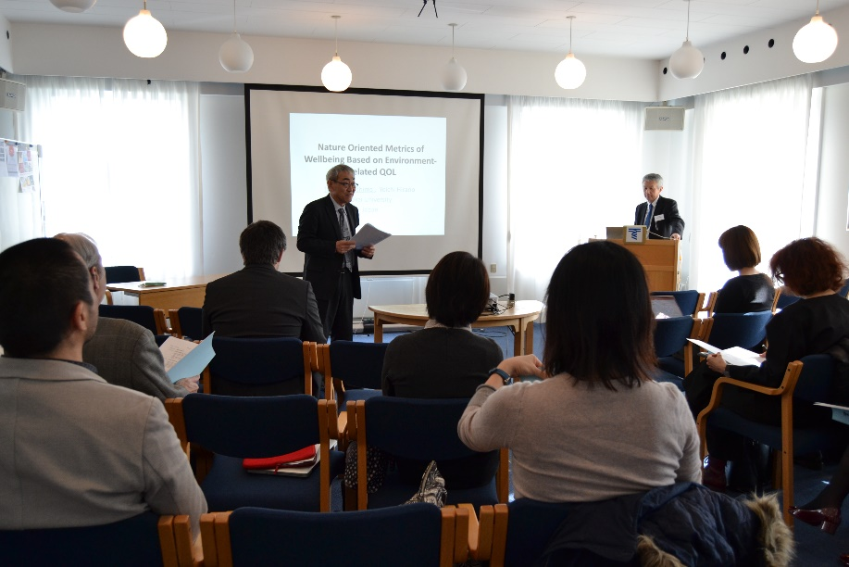

Tokai University European Center was venue for the 4th Dialogue between Civilizations symposium held on March 14th and 15th, 2019. The international symposium is a collaboration between Tokai University Institute of Civilization Research and Tokai University European Center.

The dual theme of the symposium concept is trans-disciplinary humanities and cultural psychology, fields represented respectively by Professor Yoichi Hirano and Professor Shogo Tanaka as primary organizers of the program. Since 2016, Environment has been integrated into symposium concept as a new field of study.

The two-day program consisted of sessions focusing on environmental studies, societal studies, studies on human body and mind, trans-disciplinary humanities, dialogue between civilizations and cultures and trans-disciplinary humanities (epistemological studies). In addition, keynote presentations were made by Professor Kyoko Murakami of the University of Copenhagen (Department of Psychology), and Professor Shogo Tanaka of Tokai University (Center of Civilization Research).

Themes presented and discussed during the symposium included environment-related QOL, language policy and identity formation in 19th century France, well-being, listening as dialogue, sustainable development and circular economy, bicultural identity and talent, Renaissance knowledge and concepts, negative legacies of modernization and the Japanology scholar Philipp Franz von Siebold.

Participating in the symposium from Tokai University were Professor Yoichi Hirano (School of Letters), Professor Takuo Nakashima (ICT Education Center), Professor Shogo Tanaka (Center of Civilization research), Professor Nobukata Kutsuzawa (School of Letters), Ms. Tomoko Nakamura (Center for Liberal Arts), Ms. Soji Lee (School of Business Administration), Ms. Mina Adachi (doctoral student, Graduate School of Letters) and Ji He Hsien (master’s student, Graduate School of Letters). International participants included Professor Kyoko Murakami (University of Copenhagen, Denmark), Dr. Yan Lespoux (University Paul Valery Montpellier 3, France), Dr. Denis Francesconi (Aarhus University, Denmark), Ms. Silvia Wyder (PhD candidate, University of Derby, UK), Ms. Marina Pieroni (doctoral student, The Technical University of Denmark, DTU), Ms. Kristina Kazuhara (doctoral student, Copenhagen Business School) and Professor Peter Pantzer (professor emeritus, Bonn University).

A select few from higher educational and academic milieu’s in Copenhagen were invited as audience participants to the symposium.

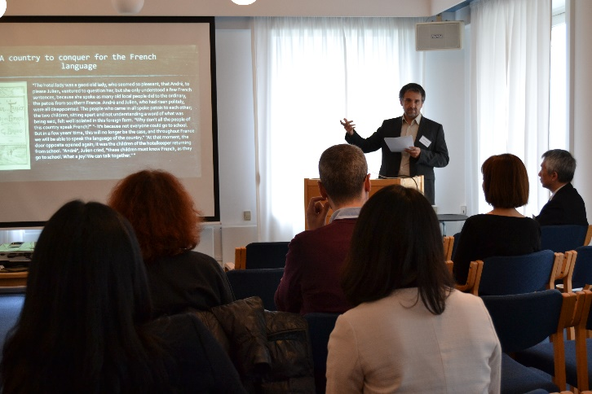
Dr. Yan Lespoux.

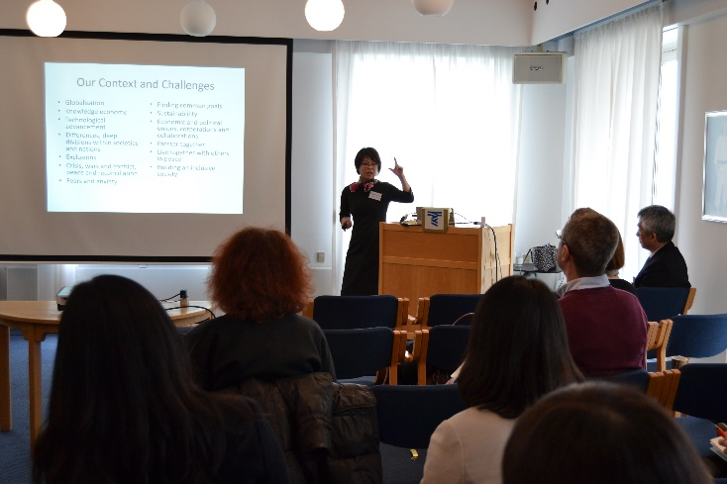
Professor Kyoko Murakami.

